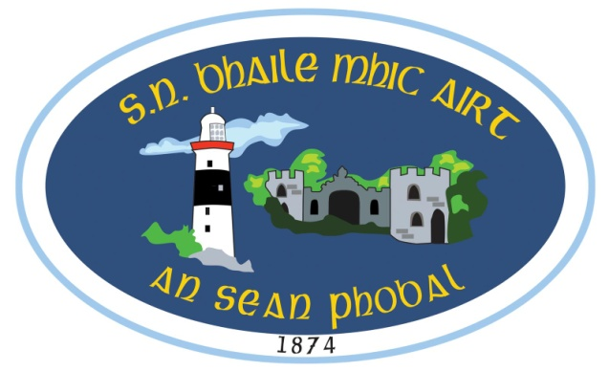

anseanphobal.ias@gmail.com - 058 46446

Foirm Iontrála 2022/2023

Ainm an pháiste Name of Child
Uimhir PPS PPS number
Seoladh baile & eircód Home address & Eircode

Dáta breithe Date of Birth
Reiligiún an pháiste Religion of the child
Dáta & áit gur bháistíodh an pháiste Date & place of Baptism
Ainm an máthair Name of mother (nó caomhnóir baineann/ or Female Guardian)
Seoladh baile Home address

Slí beatha Occupation
Uimhir baile Home no.
Uimhir guthán póca Mobile no.
Uimhir fón obair Work No.
Ainm an athair Name of father(nó caomhnóir fireann/ or Male guardian)
Seoladh Baile Home address

Slí beatha Occupation
Uimhir baile Home no.
Uimhir guthán póca Mobile no.
Uimhir fón obair Work No.

Cén duine atá ceadaithe do pháiste a bhailiú ón scoil?
Who is permitted to collect your child from school?

- Ainm name
Seoladh address
_ Fón Phone

2. Ainm name
Seoladh address
Fón Phone

3. Ainm name
Seoladh address
Fón Phone

1. Fadhbanna sláinte /Ailléirge Health Problems/Allergies
2. Ainm an dochtúra Name of Dctr
3. Uimhir an dochtúra No. of Dctr
4. An dtógann do pháiste leigheas go rialta? Does your child take medicine on a regular basis?
5. Má thógann inis dúinn cad a thógann said agus cé chomh minic is a thógann said é. If so state type and frequency of medicine taken.
6. An gcaithfidh do pháiste leigheas a thógaint fad’s atá sé/sí ar scoil. Does your child have to take medicine during school hours?

Má thógann caithfidh tú ráiteas scríofa a thabhairt don príomhoide ag rá gurb é an pháiste atá freagrach dá leigheas féin agus nach mbeidh an múinteoir ranga freagrach as é a thabhairt don pháiste nó d’aon eachtraí a d’fhéadfadh tarlú dá bharr.
If so you are required to give a written statement to the Principal stating that the child is responsible for his/her own medicine and that the class teacher will not be held responsible for the administration of the medicine or for any consequences that may arise.

Muna mbíonn tuismitheoirí ar fáil, cén duine a chuirfidh an scoil glaoch air/uirthi?
If parents are unavailable who can the school contact in the case of an emergency?

1. Ainm
Seoladh
Fón:

. 2. Ainm
Seoladh
Fón:

1. An bhfuil cead ag 1. do pháiste a bhailiú ón scoil má tá sé/sí tinn? Tá □ Níl □
Does contact 1. have permission to collect your child from school in the case of illness

2. An bhfuil cead ag 2. do pháiste a bhailiú ón scoil má tá sé/sí tinn? Tá □ Níl □
Does contact 2. have permission to collect your child from school in the case of illness

3. An bhfuil riachtanais speisialta oideachais nó mí-chumas ag do pháiste?
Does your child have special educational needs or a disability? Tá □ Níl □
(Más ‘ea cuir in iúl don príomhoide i scríbhinn le do thoil.
If yes, please inform the principal in writing. )

4. An bhfuil cead ag do pháiste freastal ar ranganna ‘Bí Sábháilte’
Does your child have permission to attend the Stay Safe Programme? Tá □ Níl □

5. I gcás citron ar scoil no tinneas an bhfuil cead do pháiste a thabhairt
díreach go dtí’n t-ospidéal?
In the case of serious accident or illness do you give permission to take your child straight to hospital? Tá □ Níl □

6. An bhfuil cead ag an scoil griangrafanna a ghlacadh de do pháiste nó
guth do pháiste a thaifead?
Does the school have permission to take photographs or voice recordings of my child? Tá □ Níl □

7. An bhfuil aon cúrsaí dlí ag baint le do pháiste?
Does any legal order, under family law, exist that the school should know about? Tá □ Níl □

8. An nglacann tú le Cód Iompair na scoile agus na rialacha atá ann? Glacaim / Ní ghlacaim
Do you accept the school’s behavioural policy and the rules within? I accept / I don’t accept

9. An bhfuil cóip den teastas breithe curtha leis an fhoirm seo?
Have you included a copy of the child’s birth certificate? Tá □ Níl □

Siniú__________________________________ Dáta______________________

